Allergy, Asthma & Immunodeficiency Clinic
3351 El Camino Real ׀ 2nd Floor, Suite 201 ׀ Atherton, CA 94306 ׀ 650-723-3200
Below you will find information about our clinic. Please take a moment to review the contents.

Prepare for your Appointment:
- Please arrive 15 minutes before your appointment.
- Please allow 1-2 hours for the initial visit.
- Please stop all antihistamine containing products and other medications listed below 7 days prior to your appointment.
- We are a teaching institution, so you may be evaluated initially by a physician-in-training under the direct supervision of a faculty member.

You must bring the following documents to your appointment:

- New Patient Questionnaire Form (enclosed). Please have this completed prior to your arrival to avoid any delay.
- Outside test results: If you are having your labs done outside of Stanford Health Care network, please ask your lab to fax the results to ****
- Arrange for copies of pertinent Medical Records, tests or x-rays to be faxed to our office at *** at least 1 week prior to your appointment.
- Bring a list of your medications, diaries which you have kept at home, or asthma related tools such as peak flow meters or spacers.

Cancellations

If you need to reschedule your appointment, please call the clinic 48 hours prior to your appointment at 650-723-3200, so we may accommodate other patients. You will also be contacted via an automated system to confirm or cancel your appointment. Please listen to the entire message as the message contains valuable information including the ability to respond “yes” or “no” to confirm or cancel your appointment.

PATIENT INSTRUCTIONS FOR SKIN TESTING
Allergy Skin Testing is done to assist your Allergist in determining what may be causing symptoms of an allergic reaction. Extracts of common allergens are pricked or injected into the superficial layers of the skin. A positive reaction resembles a small mosquito bite and typically resolves within one hour. Positive and negative skin tests must be correlated with the patient's clinical history and physical findings to determine the test’s relevance.
- Testing may take up to two hours. You may eat as usual prior to the test.
- Please wear a loose-fitting, short-sleeve, or sleeveless shirt, as we typically perform skin testing on both the lower and upper arms.
- You will be given a consent form to sign, which explains the risks and benefits of the test. You will have the opportunity to discuss questions and concerns prior to the test with your provider. Your provider will review your test results with you after the test has been completed.
- If you have questions before your visit, call us at the number listed above and ask for the Allergy nurse.

Medications to avoid 7 days prior to appointment:
Loratadine (Claritin, Alavert)
Fexofenadine (Allegra)
Cetirizine (Zyrtec, Aller-Tec, Equate Allergy Relief)
Desloratadine (Clarinex)
Levocetirizine (Xyzal)
Chlorpheniramine (Chlor-Trimeton, Atrohist, Deconamine, Rondec, Rynatan)
Hydroxyzine (Atarax, Vistaril)
Ranitidine (Zantac), Famotidine (Pepcid), Cimetidine (Tagamat)
Medications to avoid 3 days prior to appointment:
- Anything containing an anti-histamine. Examples are listed below.

Diphenhydramine (Benadryl) | Over-the-counter Allergy, Cold, and Sleep medications:
Azelastine nasal spray (Astelin) | Actifed | Robitussin Cough & Cold, Cough & Allergy
Olopatadine nasal spray (Patanase) | Alka-Seltzer Plus Cold, Flu | Advil PM, Allergy, or Multi-symptom Cold
Olopatadine eye drops | Allerest | Sine-Off
(Patanol, Pataday, Pazeo) | Comtrex | Sudafed Allergy, Severe Cold, Nighttime
Cyproheptadine (Periactin) | Contac | Theraflu products
Dimenhydrinate (Dramamine) | Coricidin | Triaminic
Ketotifen tablets | Dimetapp | Tylenol Plus, Cold, Allergy PM
Meclizine (Bonine) | Dristan tablets | Zicam Cold & Flu
Pheniramine | Drixoral | Unisom, Sominex, Simply Sleep
Promethazine (Phenergan) | Nyquil (Vicks)

- Tricyclic antidepressants: Elavil (amitriptyline), Sinequan (doxepin), Norpramin (desipramine), Tofranil (imipramine), Anafranil (clomipramine), and Pamelor (nortriptyline) will interfere with skin testing results.
You should ask the doctor who prescribed these agents, if it is safe for you to stop.

- If you are on Beta-blockers or MAO inhibitors, please let the nurse know that you are taking these medications on the day of your appointment. Your primary doctor and allergist may need to consult prior to any allergy testing.

**All of your other medications (including asthma inhalers, singulair, steroids) should be taken as prescribed.**
Allergy, Asthma & Immunodeficiency Clinic
3351 El Camino Real ׀ 2nd Floor, Suite 201 ׀ Atherton, CA 94306 ׀ 650-723-3200
Stanford Health Care Allergy, Asthma and Immunodeficiency Clinic Map

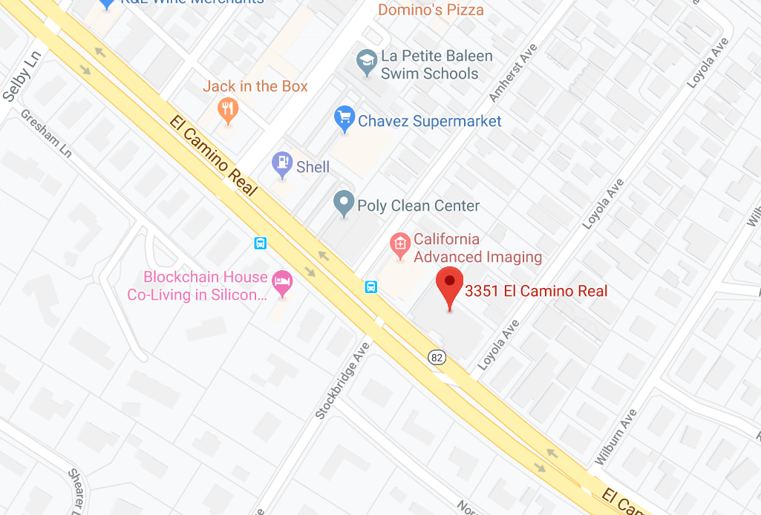
Driving Directions:
From Bayshore US Highway 101 North:
- Head south on US-101 S
- Exit Marsh Road
- Turn right on Marsh Road
- Turn right on Middlefield Road
- Turn left on Fair Oaks Lane
- Turn right on El Camino Real
- 3351 El Camino Real Atherton Square is on your right

From US Highway 280 North or South
- Take Alpine Exit from 280
- Turn Right on Alpine Road
- Follow Alpine Road to Santa Cruz Ave
- Turn Right on Sand Hill Road
- Follow Sandhill Road past Stanford Shopping Mall
- Turn Left on El Camino Real
- Follow El Camino Real for about 2 miles
- 3351 El Camino Real Atherton Square is on your right
Allergy, Asthma & Immunodeficiency Clinic
New Patient Questionnaire

Patient’s Name: Today’s Date:
Referring Doctor:
Referring Doctor’s Phone #:
Referring Doctor’s Address:
Briefly describe the reason for your visit:

- Are you currently having any of the following problems?
 | No | Yes | Other comments
Itchy eyes | □ | □
Runny nose | □ | □
Stuffy nose | □ | □
Sneezing | □ | □
Frequent nosebleeds | □ | □
Nasal Polyps | □ | □
Frequent headaches | □ | □
Frequent sinus infections | □ | □ | # in past year_____
Frequent ear infections | □ | □ | # in past year_____
Frequent lung infections | □ | □ | # in past year_____
Frequent cough | □ | □
Wheezing | □ | □
Shortness of breath | □ | □
Hives (red raised itchy rash) | □ | □
Swelling of face, tongue, or lips | □ | □
Sleep problems | □ | □

- Have you ever been diagnosed with any of the following medical conditions?
 | No | Yes | Don’t know
Allergic rhinitis | □ | □ | □
Allergic conjunctivitis | □ | □ | □
Eczema or Atopic Dermatitis | □ | □ | □
Asthma | □ | □ | □
Chronic Urticaria | □ | □ | □
Food Allergy | □ | □ | □
Drug Allergy | □ | □ | □
Mast Cell Disorder | □ | □ | □
Immunodeficiency | □ | □ | □
Other allergic disease:__________

- If you marked that you have asthma above, please answer these questions:
 | No | Yes
Have you had any emergency room or urgent care visits for asthma in the last 12 months? | □ | □
Have you received any steroid courses in the last 12 months for asthma? | □ | □ | # in past year_____
Have you had your flu vaccine this past year? | □ | □

- Have you ever had allergy testing before? □ No □ Yes
Date of testing | Who performed the testing? | Skin or blood test? | List any positive results

5. Have you had any sinus surgeries? □ No □ Yes
Date: Reason

6. Are you currently taking any medications, including prescriptions, over-the-counter medications or supplements? □ No □ Yes
If Yes, please list all medications, starting with allergy-specific medications first.
Medication | Dose | How often? | Reason | When Started
1.
2.
3.
4.
5.
6.
7.
8.
9.
10.

- Do you have any medication allergies? □ No □ Yes
If Yes, please list all medication allergies:
Medication allergy | Date of reaction | Describe the reaction

- Do any of your first-degree relatives (e.g. mother, father, siblings) have the following conditions?
 | No | Yes | If yes, who?
Allergies | □ | □
Asthma | □ | □
Eczema or Atopic Dermatitis | □ | □
Hives or swelling | □ | □
Anaphylaxis | □ | □
Immunodeficiency | □ | □
Frequent infections | □ | □

- Please complete the information below.
What is your current occupation?

Type of home (e.g. apartment, condo, single-family house):
Age of home:
How long have you lived there?
Any concern for water damage or mold growth in your home? □ No □ Yes
Is there a basement? □ No □ Yes
Type of heating:
□ Forced air □Baseboard □Electric □Radiator □ Space heater
Does the home have any of the following?
□ Air conditioner □ Air purifier □ Humidifier □ Dehumidifier
Location of carpeting: □ Bedroom □ Living room
Does your bedroom have any of the following:
□ Wall to wall carpeting □ Stuffed chair or coach □ Stuffed Animals
□ Curtains □ Feathered pillows □ Down comforter/blanket
Is your mattress encased? □ No □ Yes
Is your pillow encased? □ No □ Yes
Household animal/pets:
◊ Cats □ No □ Yes How many? _______ □ Indoors □ Outdoors
◊ Dogs □ No □ Yes How many? _______ □ Indoors □ Outdoors
◊ Other animal(s): ______________________ □ Indoors □ Outdoors
Do you smoke? □ No □ Yes
If yes, what do you smoke?________
How many packs/day? ______
Does anyone in the house smoke? □ No □ Yes
Do you drink alcoholic drinks? □ No □ Yes
If yes, how many drinks per week? ______

- Have you experienced any of the following symptoms in the past few days?
 | No | Yes |  | No | Yes
Constitutional |  |  | Gastrointestinal
Fevers | □ | □ | Nausea | □ | □
Chills | □ | □ | Vomiting | □ | □
Weight loss | □ | □ | Diarrhea | □ | □
Fatigue | □ | □ | Genitourinary
Eye |  |  | Frequent urination | □ | □
Blurred vision | □ | □ | Painful urination | □ | □
Itchy eye | □ | □ | Musculoskeletal
Red eye | □ | □ | Joint pain | □ | □
Ear, Nose, Mouth, Throat |  |  | Skin
Ear pain | □ | □ | Skin itch | □ | □
Ear discharge | □ | □ | Rash | □ | □
Nasal discharge | □ | □ | Endocrine
Post-nasal drip | □ | □ | Heat intolerance | □ | □
Sinus pressure | □ | □ | Cold intolerance
Sore throat | □ | □ | Hematologic | □ | □
Oral sores | □ | □ | Lymph node enlargement | □ | □
Hoarse voice | □ | □ | Easy bleeding
Cardiovascular |  |  | Neurologic | □ | □
Chest Pain | □ | □ | Headache | □ | □
Palpitations | □ | □ | Seizure history
Respiratory |  |  | Psychiatric
Cough | □ | □ | Anxiety | □ | □
Wheezing | □ | □ | Insomnia | □ | □
Snoring | □ | □ | Suicidal thoughts | □ | □
Shortness of Breath | □ | □ | Other

Please write anything else you would like us to know in the space below. Please be sure to bring this completed questionnaire to your first appointment. Thank you!

Office Use only:
“Your signature below indicates that you have reviewed the information contained in the entire questionnaire & that you have reviewed the pertinent or key findings with the patient and/or family. Key findings must be summarized in your progress notes.”
Attending MD signature: _______________________ Date/Time:_____________

