## Stanford Health Care Department of Pharmacy

# Pharmacy Residency Open House

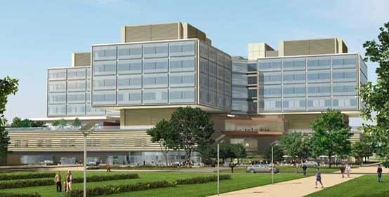

**Date and Time**

Friday,

November 15, 2019

6:00 – 8:00 pm

**Location**

Li Ka Shing Center (LKSC)

LK304/305

291 Campus Dr

Palo Alto, CA, 94305

[LKS Maps and Directions](https://med.stanford.edu/irt/about/maps-directions.html)

[Please click here to RSVP](https://forms.gle/whdDusnQJQiHziS97)

By Friday, November 1st

[Please click here to RSVP](https://docs.google.com/forms/d/e/1FAIpQLSeLbBNvaIfo-h2PpDWUpeje86OsTLg3VfkTSOloqs6JmQ1h6A/viewform?usp=sf_link)

# All PGY-1 and PGY-2 applicants are welcome!

# 

# Program Agenda

* Residency Program Overview
* Q&A with residency preceptors
* Meet-and-greet with current residents
* Facility Tour

For questions, contact: [bbetts@stanfordhealthcare.org](mailto:bbetts@stanfordhealthcare.org)

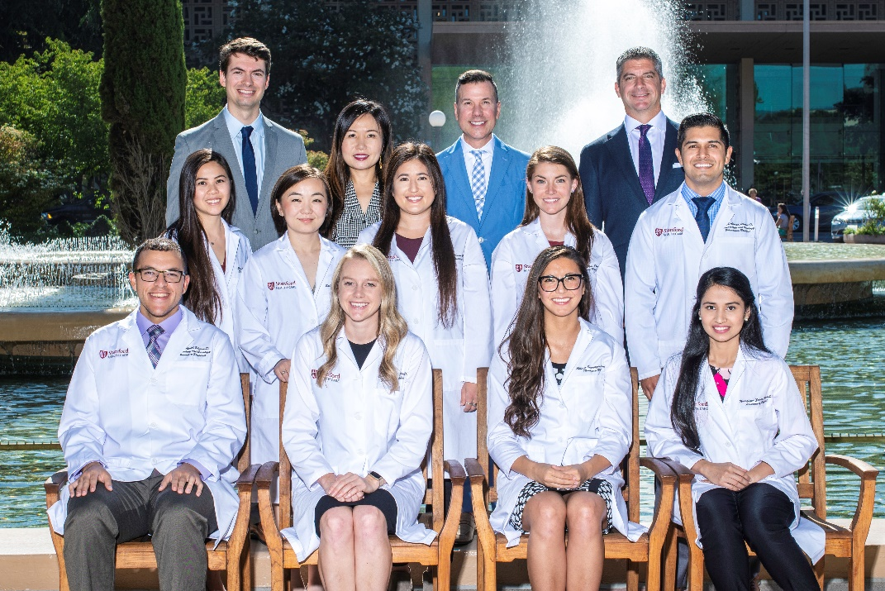



**Stanford Health Care**

300 Pasteur Drive, Room H0301

Stanford, CA, 94305