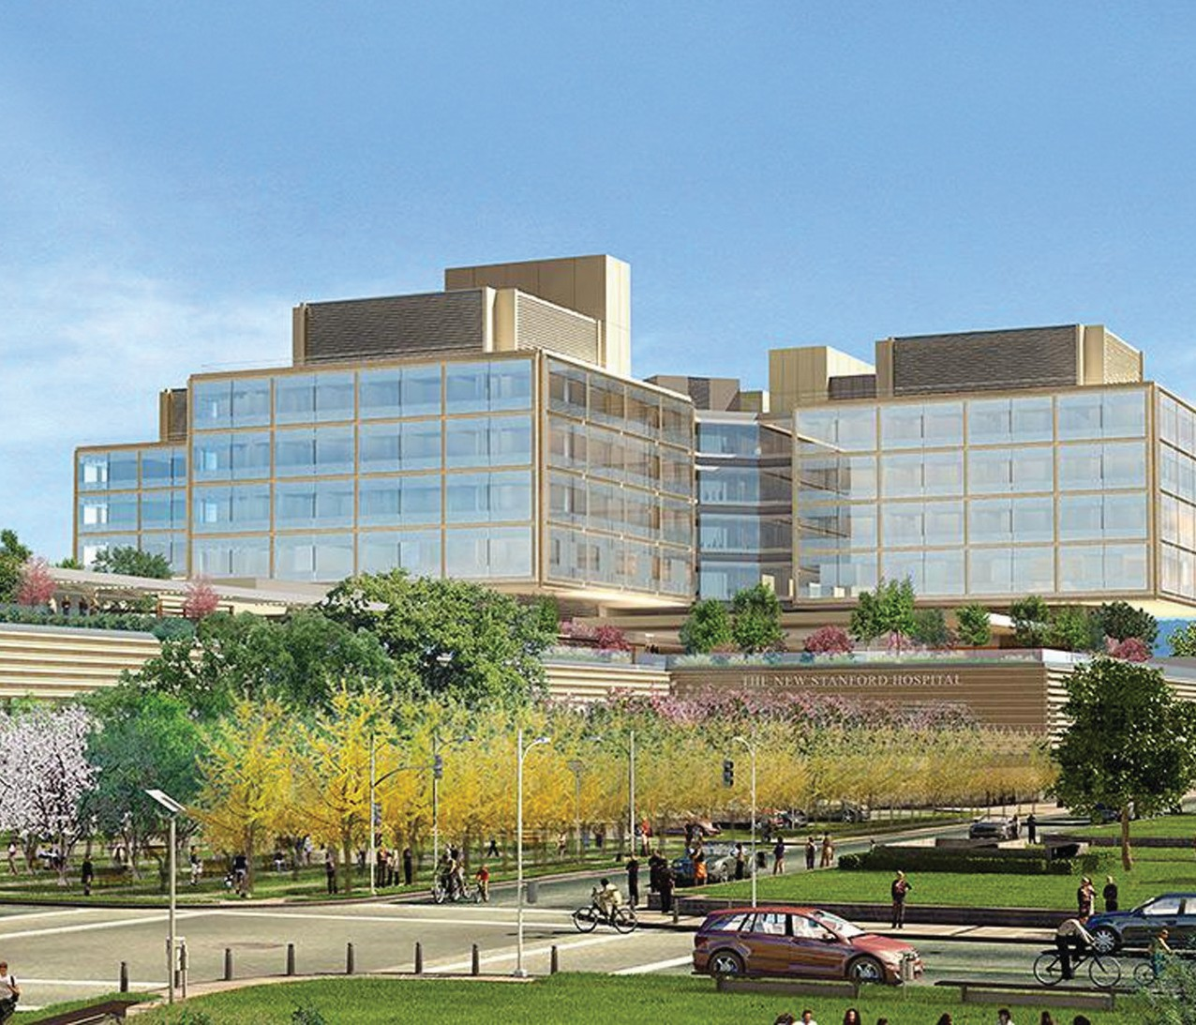
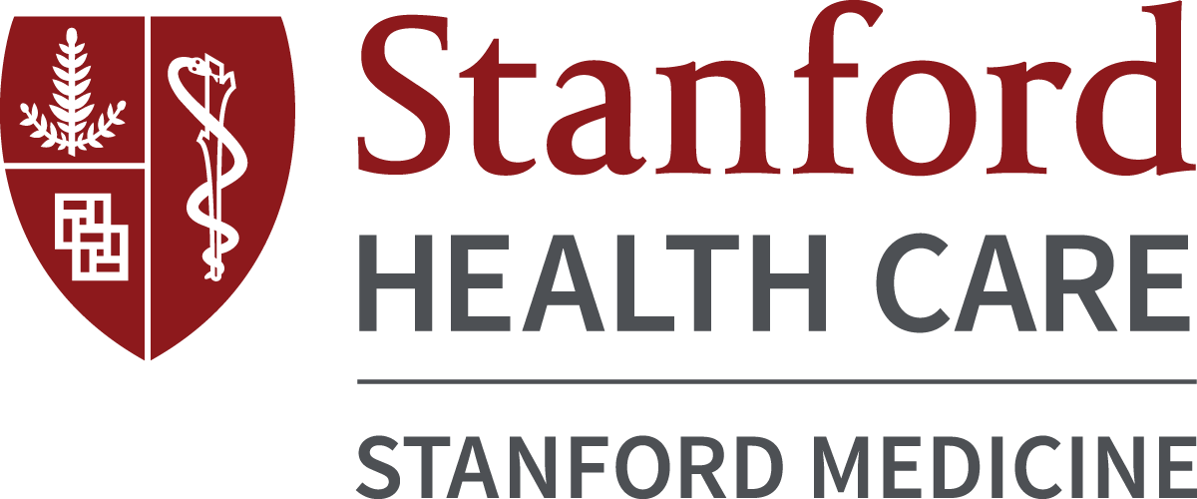

Postgraduate Year One Pharmacy Residency Program (PGY-1)
with a Transitions of Care Focus
NMS Code 170323
A career at Stanford is not just about doctors and patients. It is about taking pride in what you do, both in and out of work, and knowing that you play an integral role in something bigger. We give you the professional freedom. It is up to you how you choose to use it.

We are inviting a postgraduate year-one pharmacist to join our new Pharmacy Residency Program with a Transitions of Care Focus. Through this PGY-1 residency position, you will further your professional competence, expand your clinical knowledge and develop a philosophy of pharmacy practice in a facility that’s committed to providing an exceptional healthcare experience to its patients.

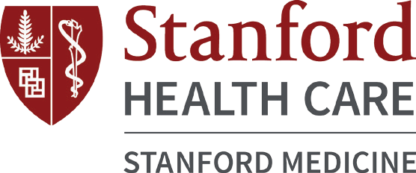

The residency program will offer you clinical training and mentorship through a variety of transitions of care pharmacy experiences, in addition to acute care and administrative training throughout Stanford Health Care.
The purpose of this residency program is to develop skills in chronic disease management, education, leadership, and practice management.

Program Goals
- Provide optimal clinical and operational pharmaceutical care to patients in multiple practice settings
- Function as effective members of healthcare teams
- Educate healthcare professionals, students, patients and the community
- Ensure appropriate medication use and safety
- Develop excellent written and verbal communication skills
- Demonstrate time management and problem-solving skills
- Become leaders within the pharmacy profession

Practice Areas
Orientation/Training (2 weeks)
Ambulatory Care (longitudinal rotation)
Anticoagulation Clinics, Primary Care Clinics
Acute Care (2 required rotations, 4 weeks/rotation)
Internal Medicine and Transitions of Care
Staffing (4 weeks)
Neuroscience or Specialty Pharmacy
Practice Management (8 weeks)
Elective Rotations (5 rotations, 5 weeks/rotation)
Ambulatory Surgery, Endocrinology, Heart/Lung Transplant, Pain Clinic, Pulmonary Clinic, Senior Care Clinic, Specialty Pharmacy, and additional opportunities may be available at other partnering institutions

Residency Requirements
- Complete and present a longitudinal research project at the Western States Conference
- Participate in teaching activities with students
- Prepare presentations for various committees including P & T Committee
- Present a Continuing Education lecture to peers
- Staff 16 hours per month on weekends in Neuroscience or Specialty Pharmacy
- Membership in pharmacy and hospital committees
- Prepare and present a BCPS Forum for co-residents and SHC pharmacists

Compensation/Benefits
Residents receive a competitive annual stipend (approximately
$54,000) with full benefits, including an excellent healthcare benefits package and 10 days paid time off. In addition, residents will enjoy educational leave and a stipend to participate at various pharmacy conferences throughout the year.

Qualifications
Participation in our PGY-1 Pharmacy Residency Program requires a Pharm.D. degree from an ACPE-accredited College or School of Pharmacy and enrollment in the ASHP Residency Match Program (www.natmatch.com/ashprmp/reglink.htm) NMS Code 170323

Residents must be licensed by the California Board of Pharmacy as an Intern at the time of hire (or within 30 days if candidate is from out of state) and be licensed by the California Board of Pharmacy as a Pharmacist by October 1, 2020. In order to achieve this, the resident is strongly encouraged to take the CPJE exam by the end of June.

Application Process
For application requirements, please visit our website at stanfordhealthcare.org and search “Pharmacy Services” to be directed to the “Allied Healthcare: Pharmacy Services” home page.
(http://stanfordhealthcare.org/healthcare-professionals/ allied-healthcare/pharmacy-services.html)
Selected applicants will be required to visit Stanford Health Care for an on-site interview in February 2020. The candidate is required to give a 15-minute PowerPoint presentation on a pharmacy-related topic. For consideration, the online application and all supporting documentation must be received by December 31, 2019.
Contact: stanfordpgy1@stanfordhealthcare.org.

Postgraduate Year One Pharmacy Residency Program (PGY-1) with a Transitions of Care Focus

