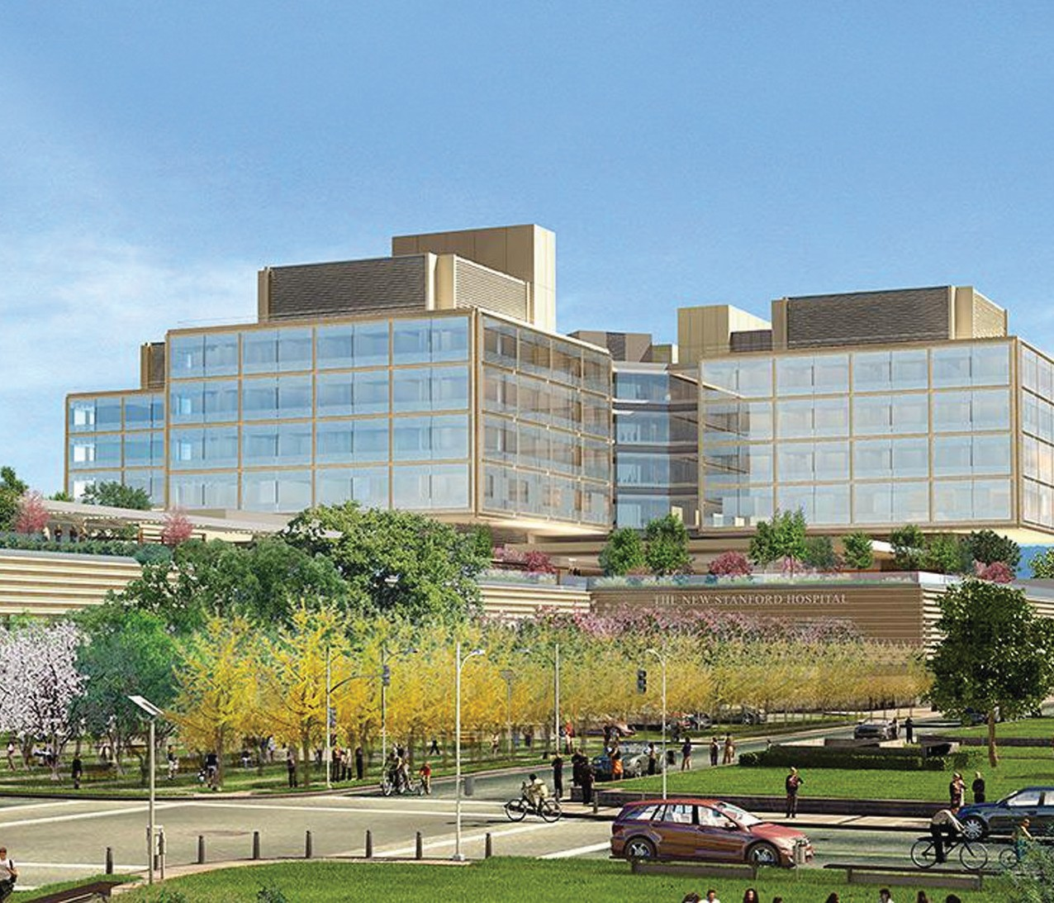

Postgraduate Year Two Pharmacy Residency Program (PGY-2) Health-System Pharmacy Administration and Leadership
NMS Code TBD
A career at Stanford is not just about doctors and patients. It is about taking pride in what you do, both in and out of work, and knowing that you play an integral role in something bigger. We give you the professional freedom. It is up to you how you choose to use it.

We are inviting a postgraduate year-two pharmacist to join our new Pharmacy Residency Program in Health-System Pharmacy Administration and Leadership. Through this PGY-2 residency position, you will further your professional competence, expand your impact as a leader, and develop a philosophy of pharmacy practice in a facility that’s committed to providing an exceptional healthcare experience to its patients.

The PGY-2 Health-System Pharmacy Administration and Leadership Residency at Stanford Health Care is a 12-month program that is applying for pre-candidate status by the American Society of Health-Systems Pharmacists (ASHP). The program provides residents a foundational learning experience for developing a pharmacy leader capable of executing positive change across a health care system. The Stanford Health Care system includes an academic medical hospital, along with more than 60 clinics and centers throughout the Bay Area. This expansive enterprise provides abundant opportunities for diverse learning experiences to our administrative resident. The PGY2 HSPA resident at SHC is to gain experience in areas of safety and medication use systems, quality assurance, human resource management, financial resource management, use of technology, and advanced leadership.
Program Goals
- Train highly motivated new practitioners as they develop into capable and effective leaders
- Advocate for advancement of pharmacy practice within the organization
- Become an integral part of the pharmacy and hospital leadership team
- Develop critical thinking and problem-solving skills in a fast-pace, dynamic work environment
- Practice and refine skills of strategic planning, project management, financial strength, and quality assurance
Practice Areas
- Orientation/Training
- Inpatient Service Management
- Ambulatory Service Management

Application Process
For application requirements, please visit our website at stanfordhealthcare.org and search “Pharmacy Services” to be directed to the “Allied Healthcare: Pharmacy Services” home page.
(http://stanfordhealthcare.org/health-care-professionals/allied-healthcare/pharmacy-services.html)
Selected applicants will be required to visit Stanford Health Care for an on-site interview in February 2020. The candidate is required to give a 15 minutes PowerPoint presentation. For consideration, the online application and all supporting documentation must be submitted via PhorCAS and received by December 31, 2019. NMS Code: TBD.
Contact: DSisodiya@stanfordhealthcare.org
- Outpatient/Specialty Management
- Executive Leadership
- Business Operations and Supply Chain Management
- Pharmacy Quality and Regulatory Compliance
- Elective Rotations
Residency Training
- Active participation within pharmacy and hospital leadership teams
- Prepare presentations for various health system committees
- Attendance at relevant professional conferences
- Complete longitudinal health-system administrative research project and present at the Western States Conference and/or other professional conferences
- Preceptorship of PGY1 Residents and students
- Staff 16 hours per month

Compensation/Benefits
Residents receive a competitive annual stipend (approximately $83,000) with full benefits, including an excellent healthcare benefits package and 10 days paid time off. In addition, residents will enjoy educational leave and a stipend to participate at various pharmacy conferences throughout the year.

Qualifications
Participation in our Specialized Residency in Health-System Administration and Leadership requires a PharmD degree from an ACPE-accredited College or School of Pharmacy and completion of an ASHP-accredited PGY-1 residency program.

The resident must be licensed by the California Board of Pharmacy as an Intern at the time of hire (or within 30 days if candidate is from out of state) and be licensed by the California Board of Pharmacy as a Pharmacist within 3 months.

Postgraduate Year Two Pharmacy Residency Program (PGY-2) Health-System Pharmacy Administration and Leadership

