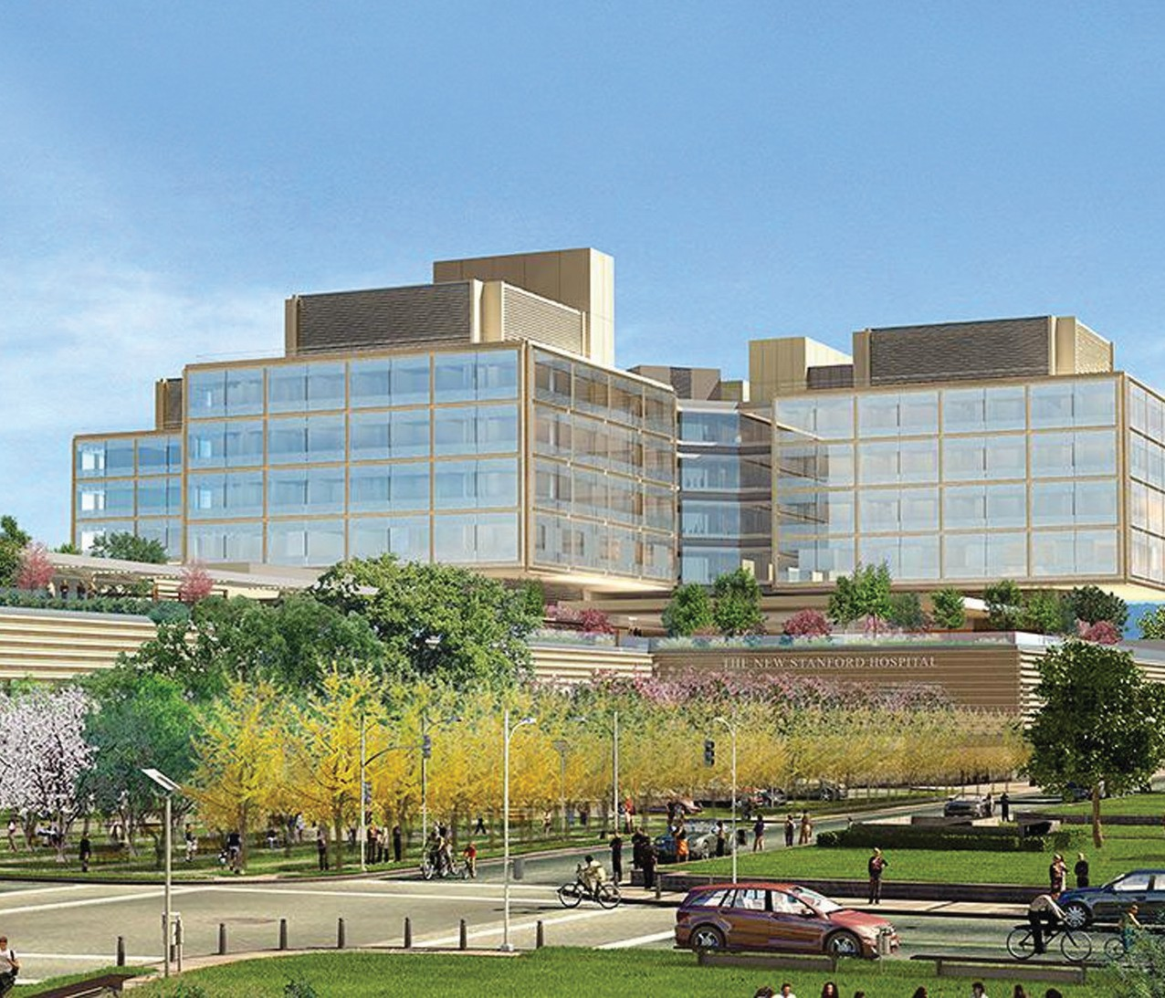
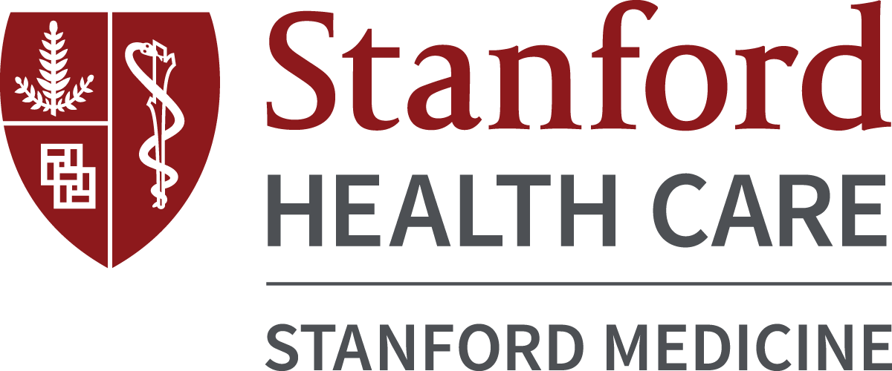

Postgraduate Year Two (PGY-2) Infectious Diseases (ID) Pharmacy Residency Program
NMS Code TBD
A career at Stanford is not just about doctors and patients. It is about taking pride in what you do, both in and out of work, and knowing that you play an integral role in something bigger. We give you the professional freedom. It is up to you how you choose to use it.

We are inviting a PGY-2 resident to join our new ID Pharmacy Residency Program. Through our program you will further your professional competence, expand your patient care and research abilities, and develop a philosophy of practice excellence in a leading healthcare system committed to providing an exceptional healthcare experience to its patients.

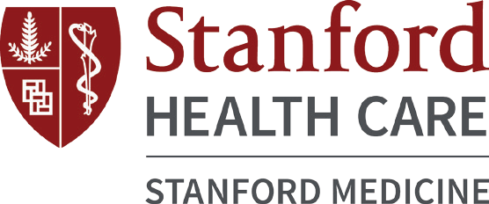

The Stanford Antimicrobial Safety and Sustainability program is recognized as an Infectious Diseases Society of America (IDSA) Center of Excellence and a World Health Organization (WHO) Collaborating Centre for Antimicrobial Resistance and Stewardship. The residency program will offer the resident clinical training and mentorship through a variety of experiences in infectious diseases and antimicrobial stewardship.

The purpose of this program is to advance the resident’s knowledge in infectious diseases pharmacotherapy, cultivate aptitude and passion for clinical research, and develop the skills needed to promote the safe and effective use of antimicrobials as a member of a multidisciplinary team.

Program Goals

- Provide optimal clinical care to patients with infectious diseases
- Function as an effective member of the healthcare team
- Educate healthcare professionals, students, patients and the community about antimicrobials and antimicrobial resistance
- Develop excellent written and verbal communication skills
- Demonstrate time management and problem-solving skills
- Become a leader within the pharmacy profession

Practice Areas
- Orientation/Training (2 weeks)
- General ID consult service (8 weeks)
- Immunocompromised ID consult service (4-8 weeks)
Hematology/Oncology and Bone Marrow Transplant Focus
- Immunocompromised ID consult service (4-8 weeks)
Solid Organ Transplant Focus
- Clinical Microbiology (4 weeks)
- Antimicrobial Stewardship (8 weeks)
Clinical and Administrative Focus
- Elective Rotations (2-4 weeks/rotation)
Pediatric ID, Hematology/Oncology, Medical/Surgical Intensive Care Unit, Solid Organ Transplant, HIV Clinic, and Emergency Medicine

Application Process

For application requirements, please visit our website at the following link:

https://stanfordhealthcare.org/health-care-professionals/allied-healthcare/pharmacy-services.html
Selected applicants will be required to visit Stanford Health Care for an on-site interview in February 2020. The candidate is required to give a 30-minute PowerPoint presentation on an ID-related topic. For consideration, the online application and all supporting documentation must be received by December 31, 2019.
Contact: abx@stanfordhealthcare.org

Residency Requirements
- Complete and present a longitudinal research project at a national conference
- Complete and present findings of a quality improvement initiative at Stanford Health Care (SHC)
- Development of an institutional clinical guideline or pathway
- Participate in teaching activities with residents and/or students
- Participate in SHC Antimicrobial Subcommittee
- Present a Continuing Education lecture to peers
- Staff one weekend per month

Compensation/Benefits
Residents receive a competitive annual stipend (approximately
$83,000) with full benefits, including an excellent healthcare benefits package and 10 days paid time off. In addition, residents will enjoy educational leave and a stipend to participate at various pharmacy conferences throughout the year.

Qualifications
Participation in our PGY-2 ID Residency Program requires completion of an ASHP-accredited PGY-1 program and a Pharm.D. degree from an ACPE-accredited College or School of Pharmacy and enrollment in the ASHP Residency Match Program (www.natmatch.com/ashprmp/reglink.htm) NMS Code TBD

Residents must be licensed by the California Board of Pharmacy as an Intern at the time of hire (or within 30 days if candidate is from out of state) and be licensed by the California Board of Pharmacy as a Pharmacist by October 1, 2020. In order to achieve this, the resident is strongly encouraged to take the CPJE exam by the end of June.

